

**Department of Computer Science & Engine**

**Course Code: CSE 404**

**Course Title: Artificial intelligence and Experts Systems lab**

**Assignment 3**

|  |  |
| --- | --- |
| **Submitted By**  **------------------------------------------------**  **Rumman Ahmed Prodhan**  **ID: 18101018**  **Section: A1**  **Semester & Year:4-1** | **Submitted To**  **----------------------------------------------**  **Molla Rashied Hussein**  **Assistant Professor**  **Department of CSE**  **UAP** |

**Problem Statement:**

1. Implement the Linear Regression Raw code in that dataset.  
2. Implement the Linear Regression Model code in that dataset.  
3. Show graphs and compare values.

**Dataset:**

Dataset Link: <https://www.kaggle.com/nehalbirla/vehicle-dataset-from-cardekho?select=car+data.csv>

This dataset contains information about used cars.  
This data can be used for a lot of purposes such as price prediction to exemplify the use of linear regression in Machine Learning.  
The columns in the given dataset are as follows:

1. name
2. year
3. selling_price
4. km_driven
5. fuel
6. seller_type
7. transmission
8. Owner

**Code Explanation**

**1. Implement the Linear Regression Raw code in that dataset:**

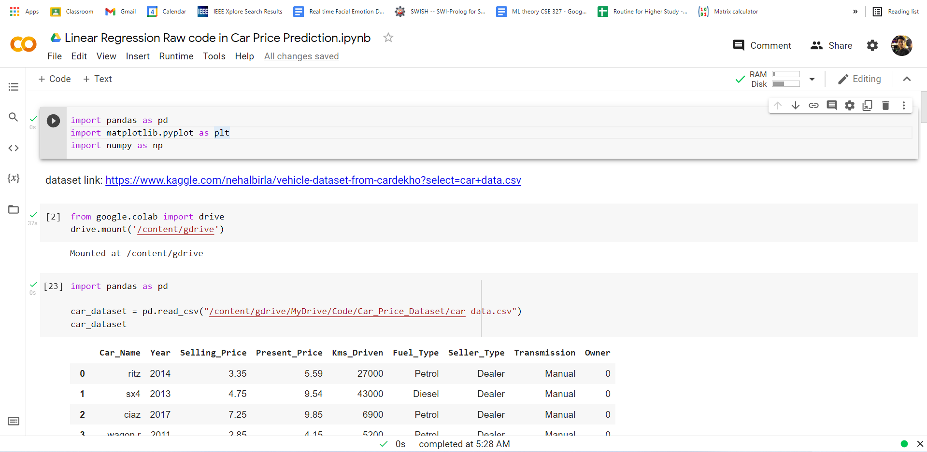

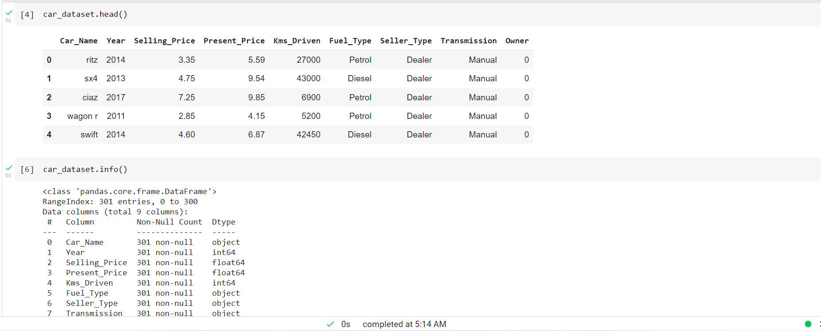 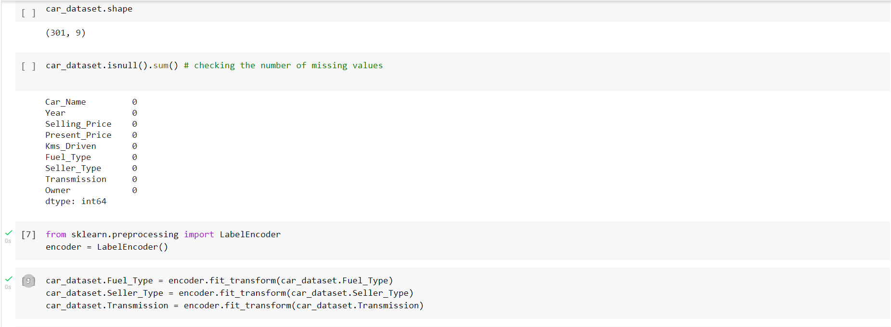 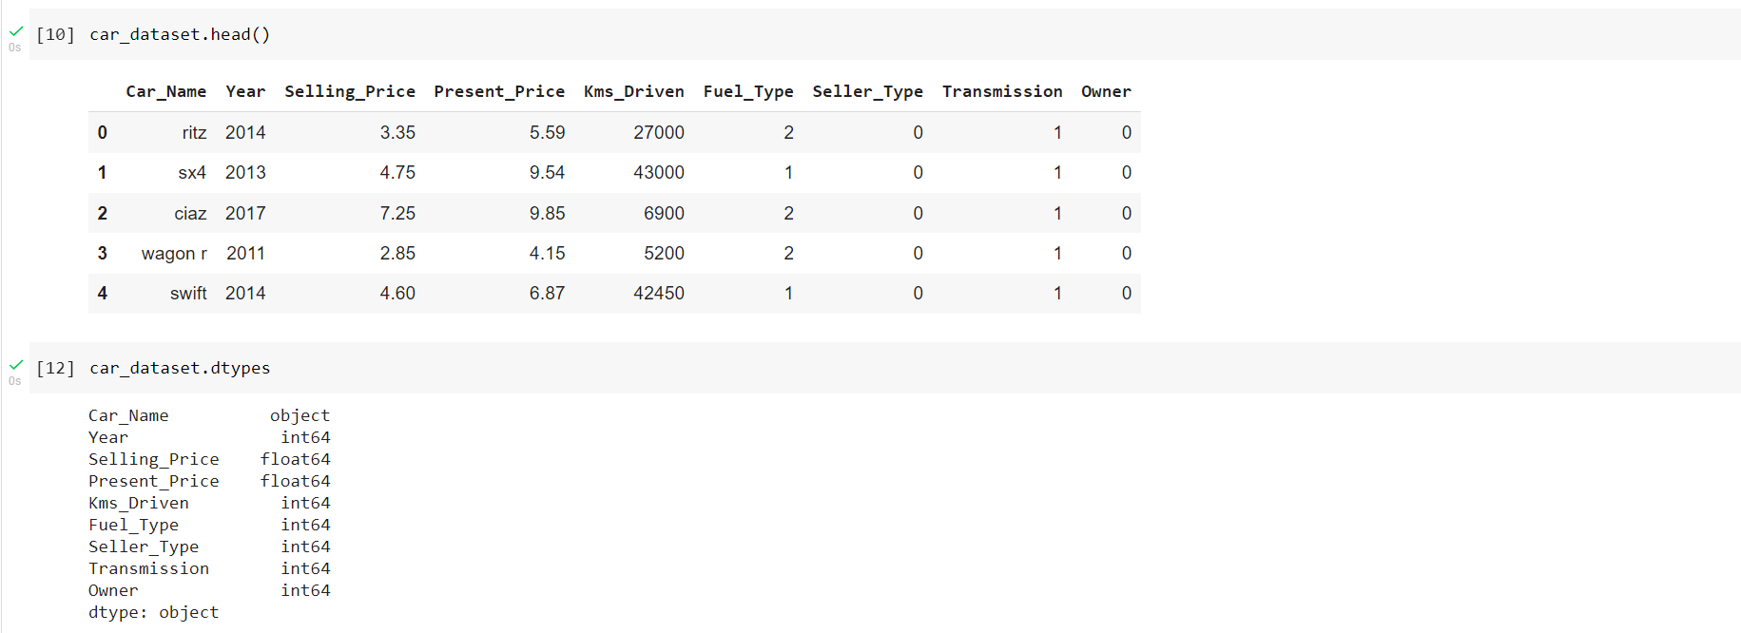 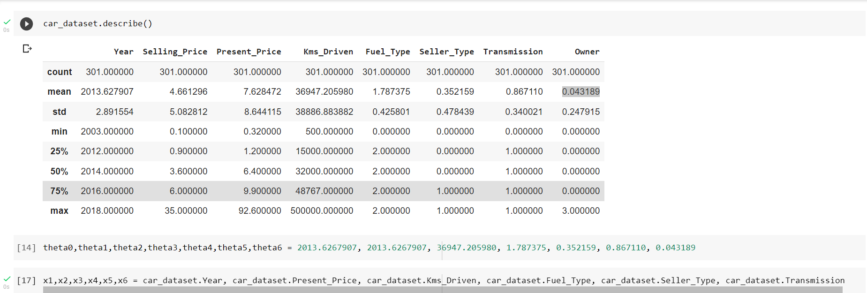 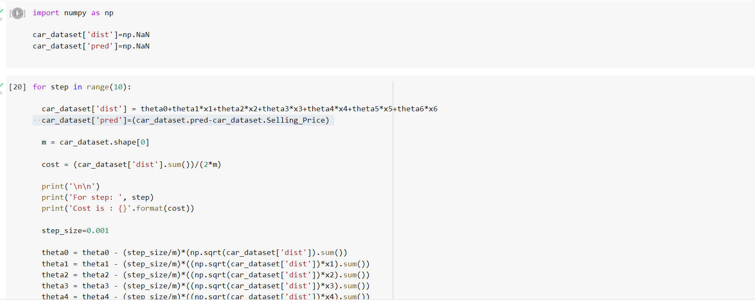 

**Output:**

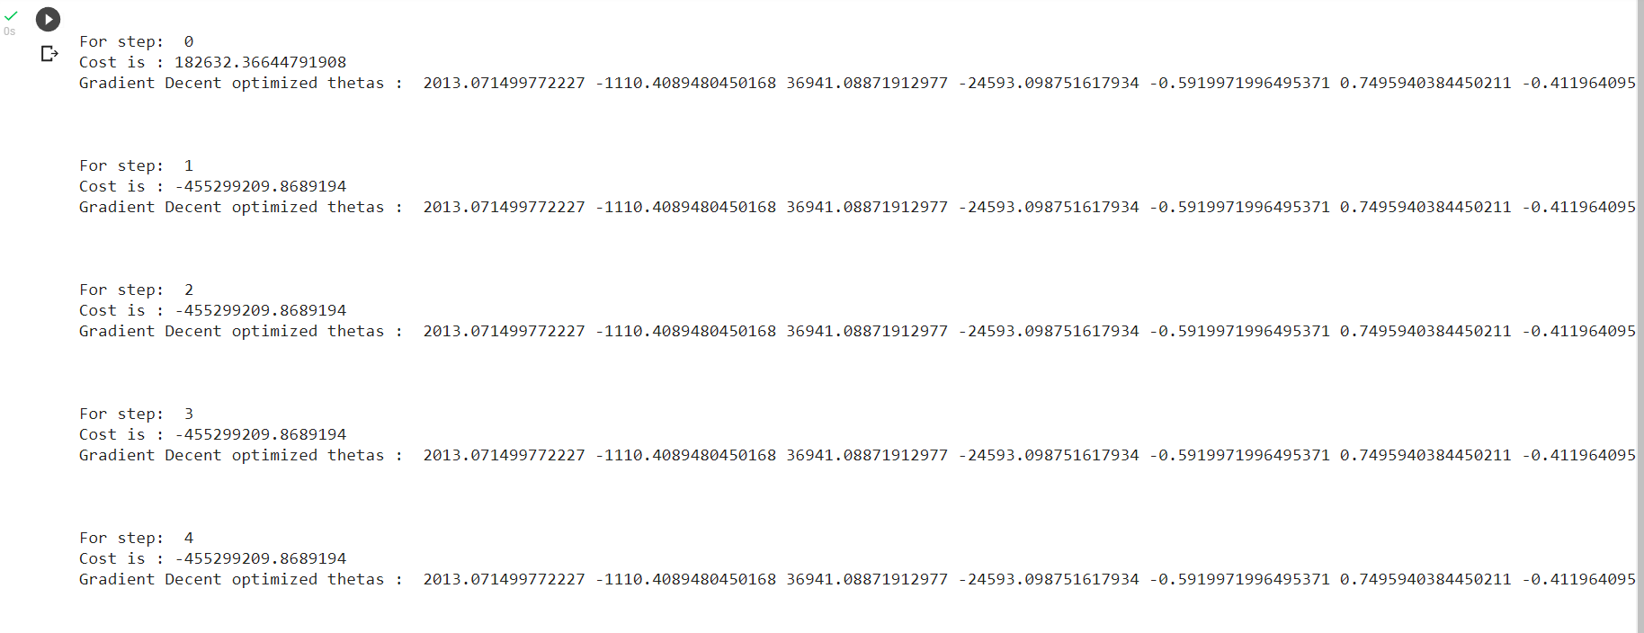

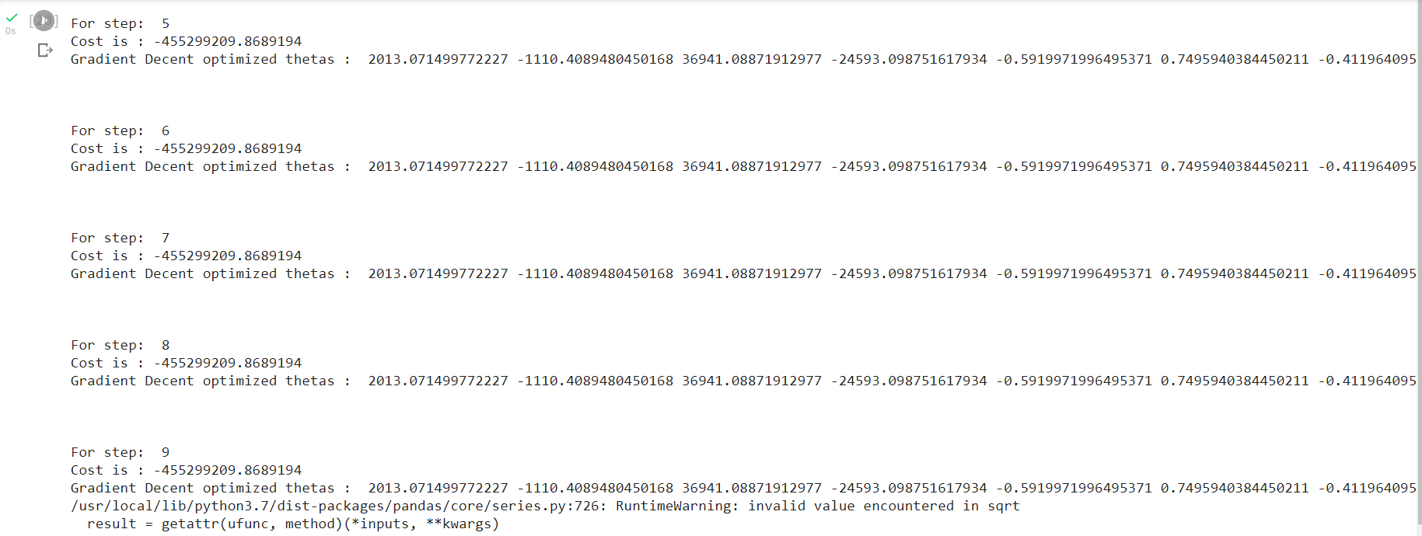

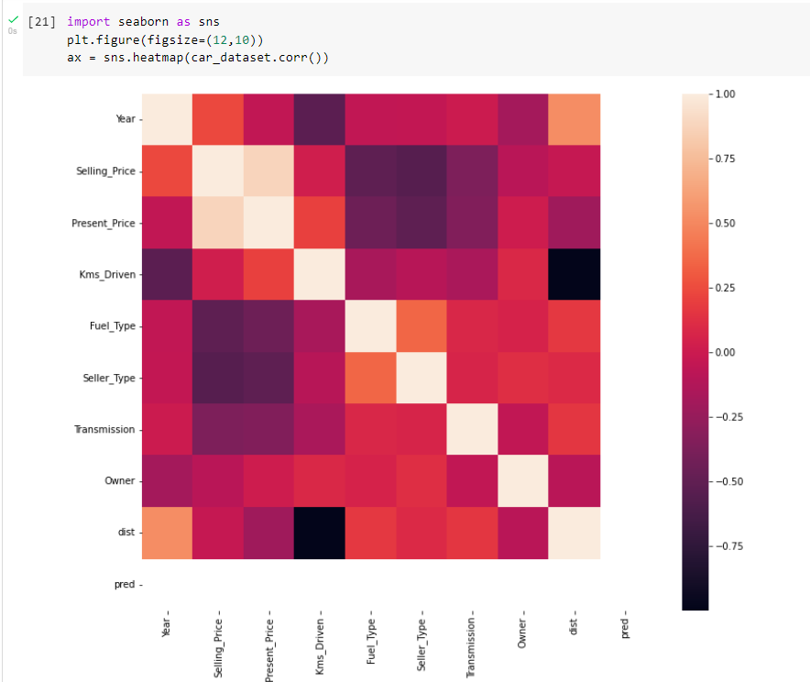

**2. Implement the Linear Regression Model code in that dataset:**

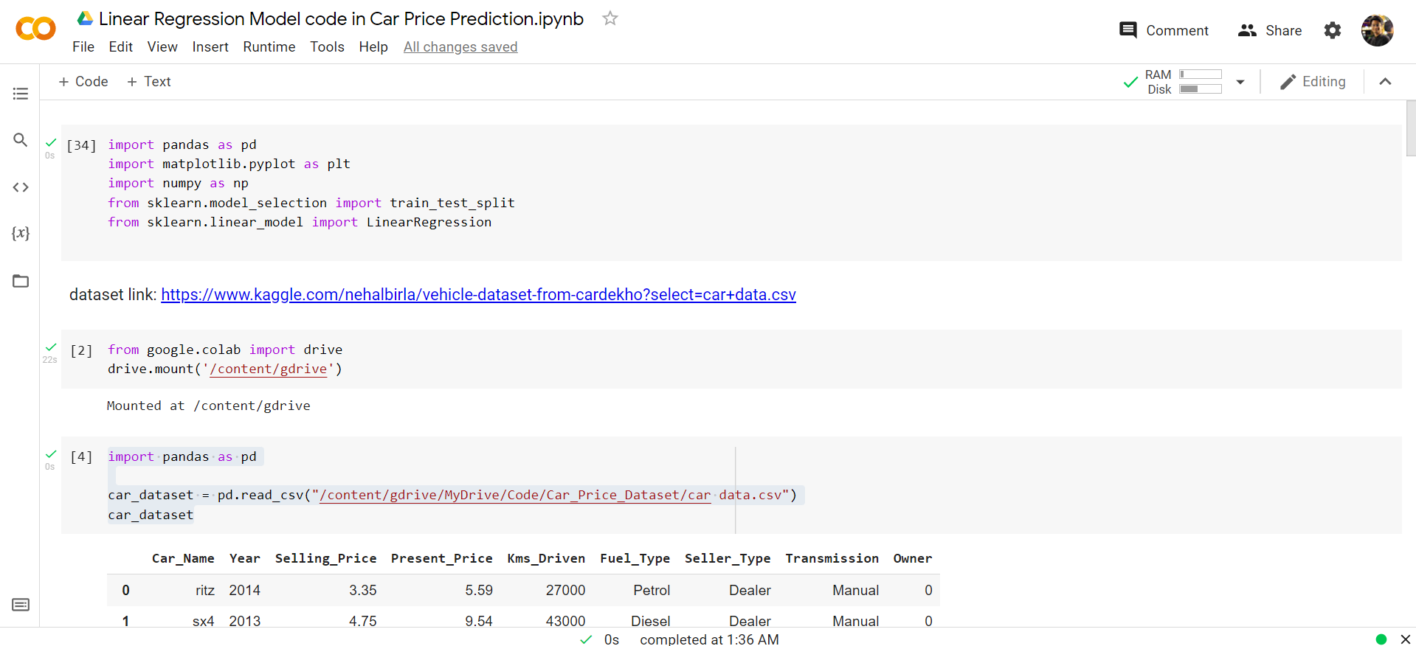

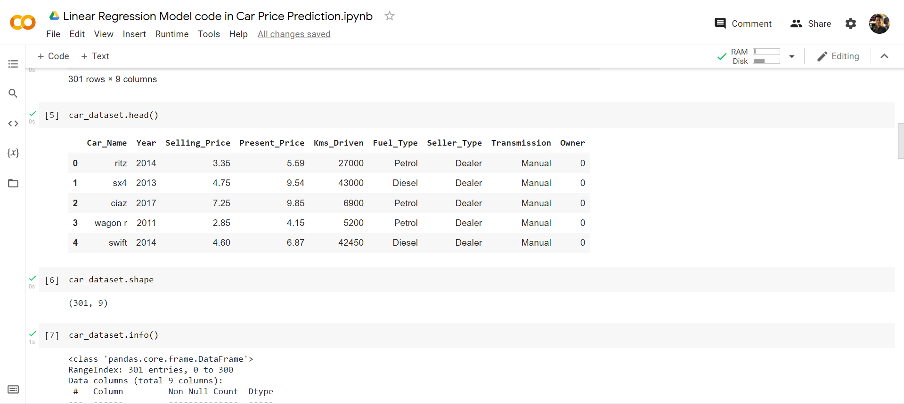

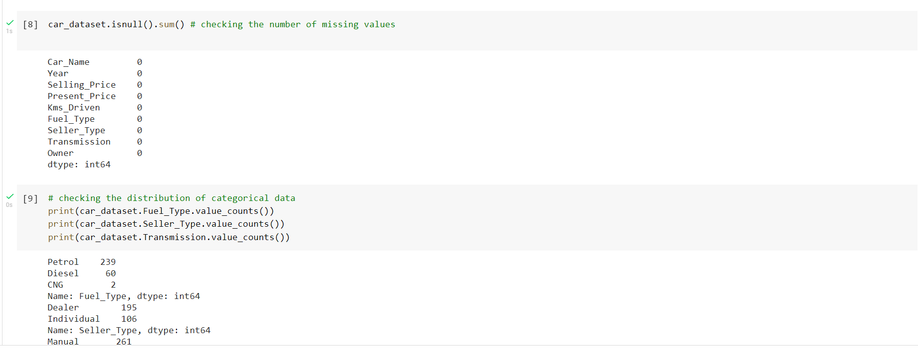

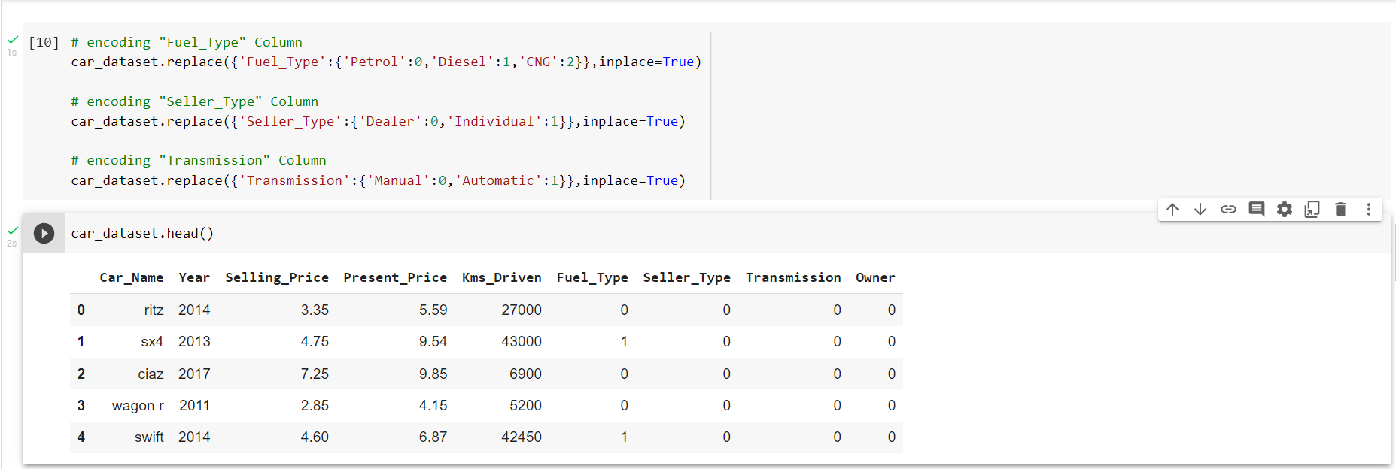

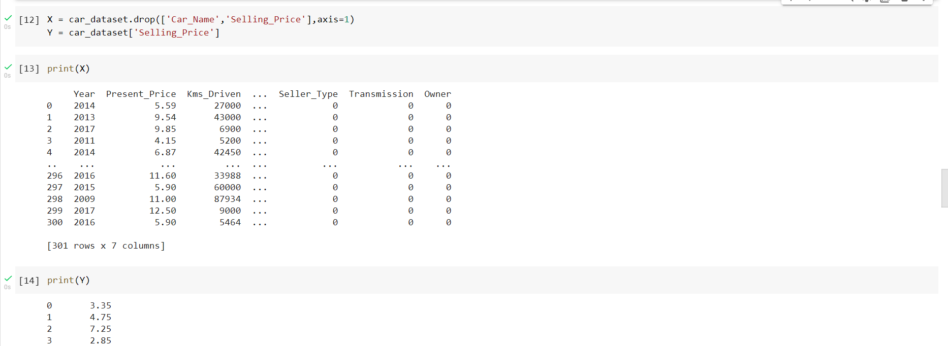

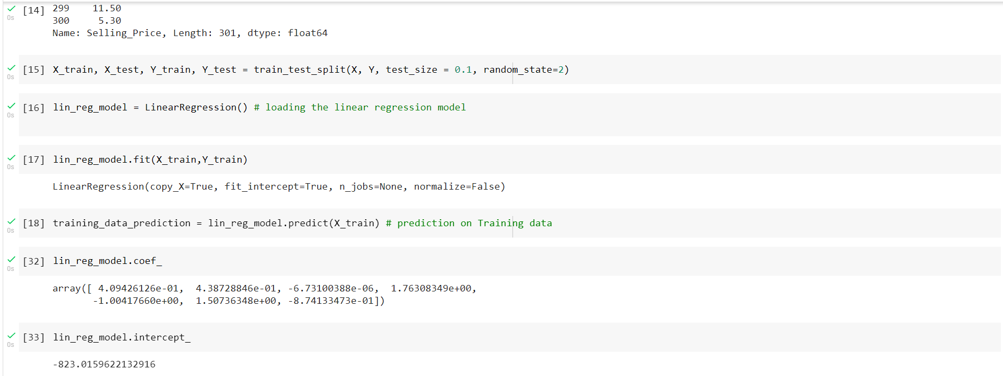 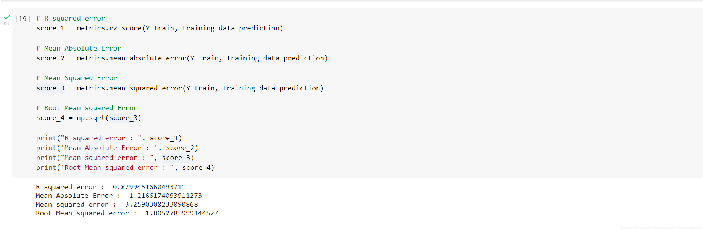

**Output:**

